|  |  |  |  |  |  |
| --- | --- | --- | --- | --- | --- |
| Date | 6-Dec-22 | | | Tester Name | Mayuri Patel |
| Environment | Penfax - Test | | | Login used |  |
| Operating System | Select OS | Version: | Update: | | |
| Software Used | Select Software | Version: | Update: | | |
| Select Software | Version: | Update: | | |
| Release version | 22.4.1 | | | | |
| Title |  | | | | |
| Test Type | Regression | | | | |
| Test Scenario | Set up payments from a prorated fund | | | | |
|  |  | | | | |
| Expected Results |  | | | | |
| Pass/Fail | Pass | | | JIRA# | N/A |

Describe your steps with screenshots:

Find a member who has more than one fund and open that member profile

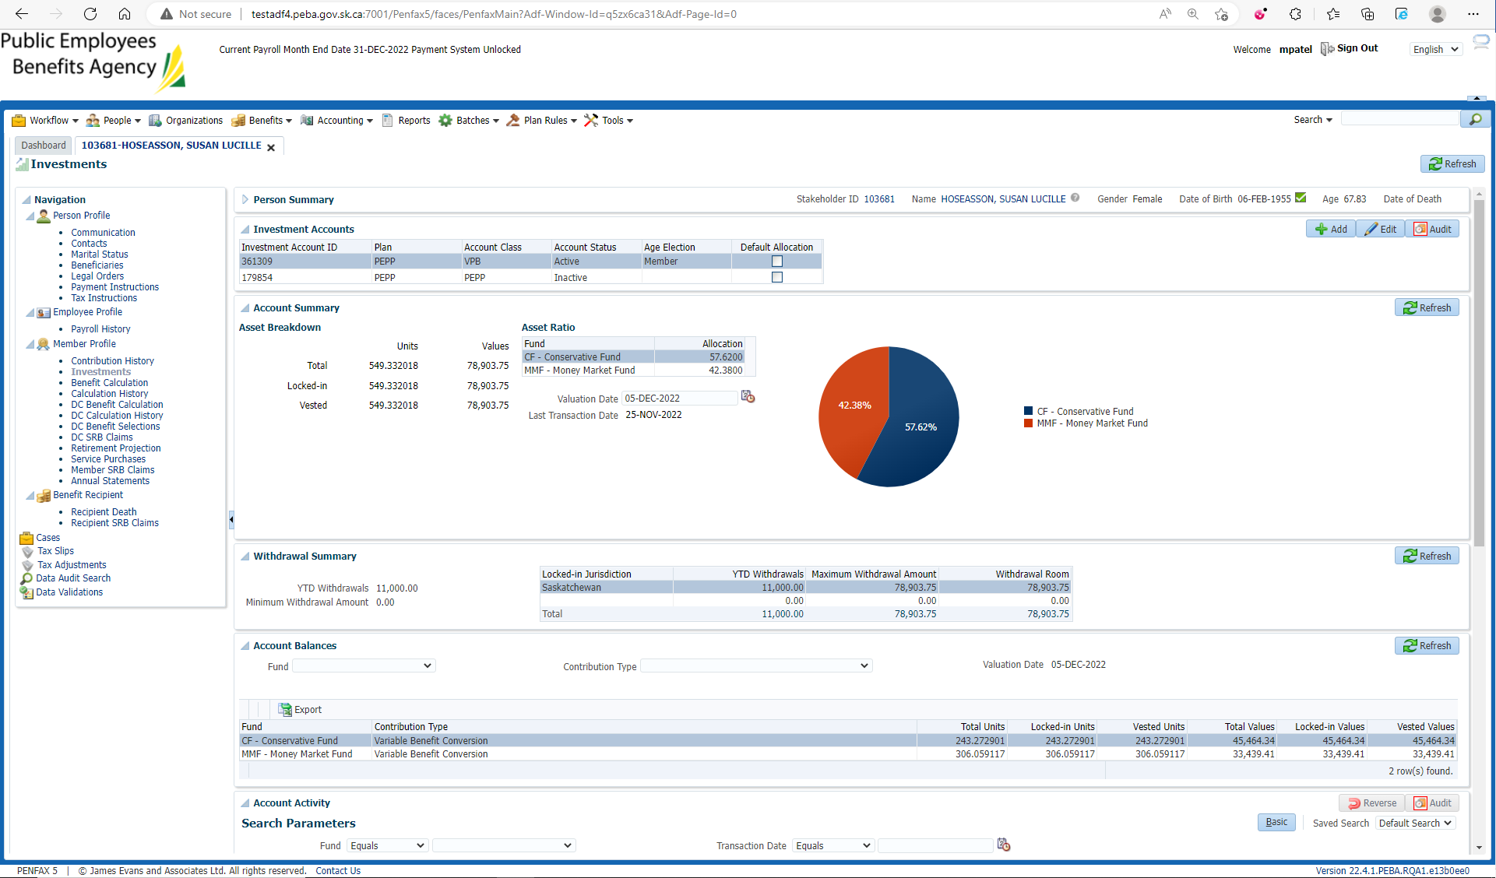

Investments🡪 Account instructions

Add Account Instruction

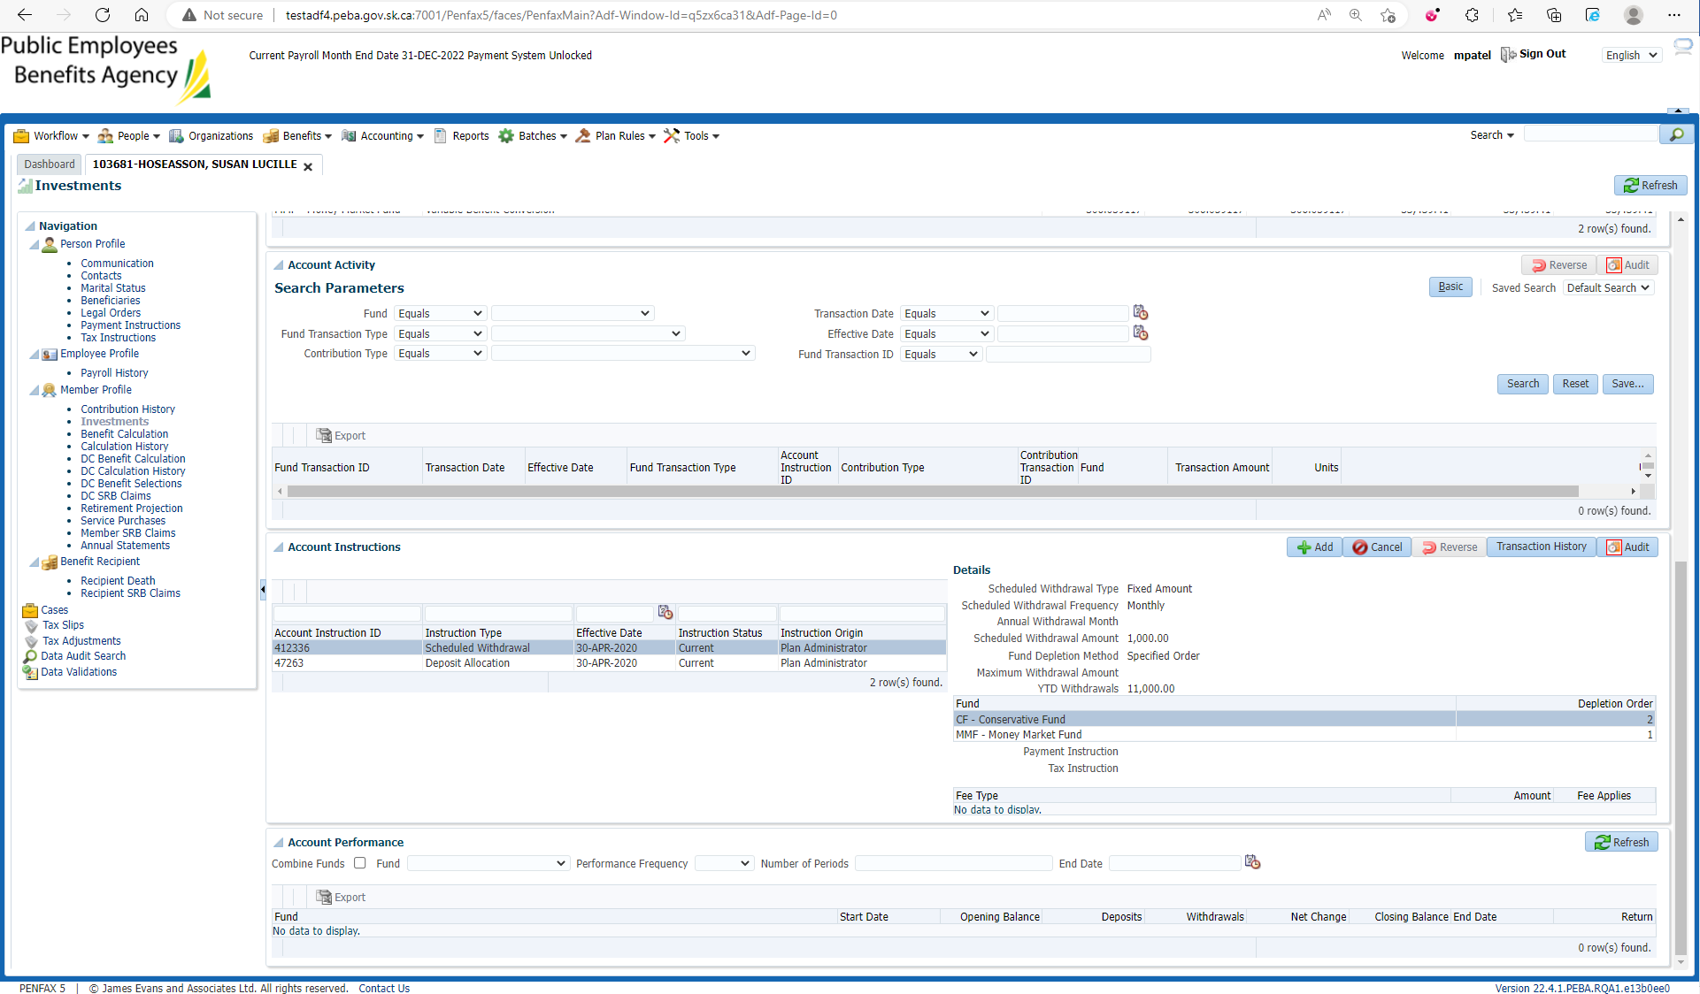

Enter mandatory details, fund depletion method to prorated and Save

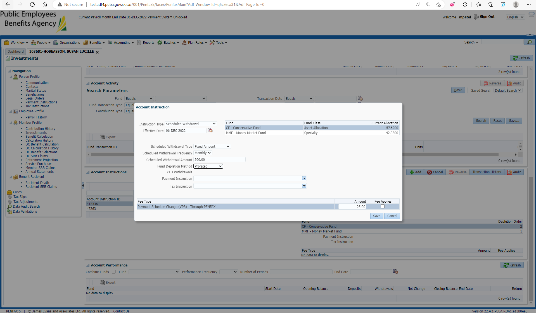

Newly entered Instruction is current and the previous one is completed now

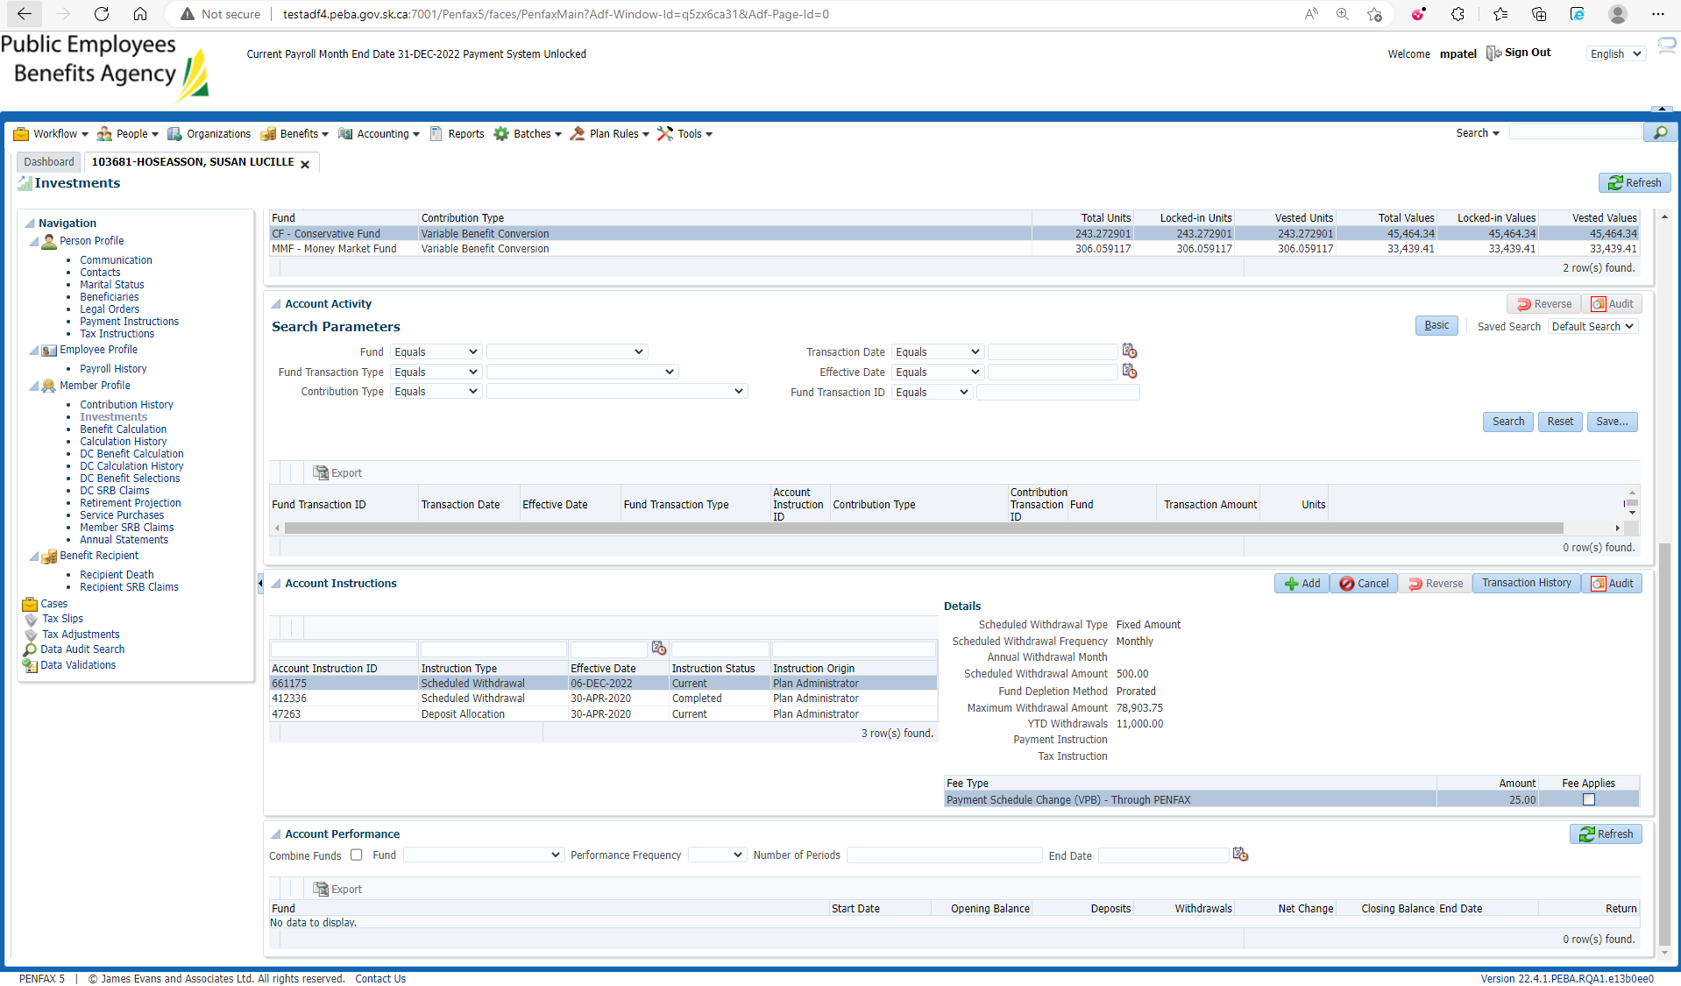

Same steps processed through Penweb

